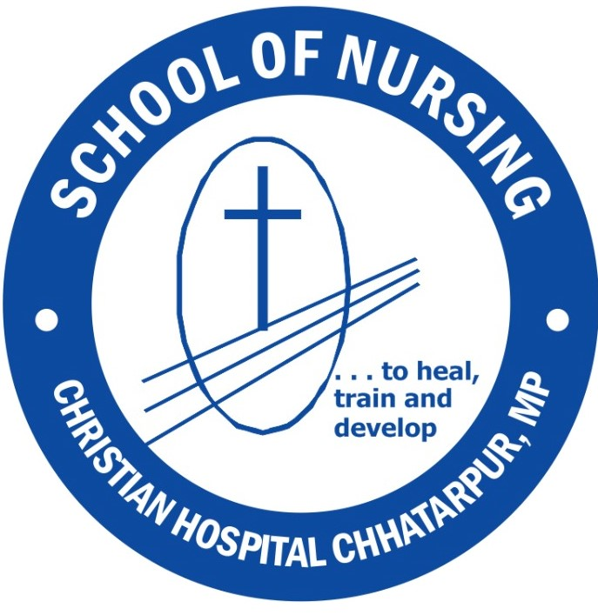- | SCHOOL OF NURSING, CHRISTIAN HOSPITAL CHHATARPUR, BETHESDA HOSPITAL SOCIETY  (A unit of Emmanuel Hospital Association, New Delhi)  (Recognized by the Indian Nursing Council and M.P. Nursing Council, affiliated to Mid India Board of Education)

Application No: Roll No.

Category: Sponsored ◻  General ◻ | School of Nursing, Christian Hospital Chhatarpur.  Dist Chhatarpur, Madhya Pradesh – 471001  Ph: 07682-249317 or 07869965406  Email: schoolchc@eha-health.org

Application for Admission to GNM Training 2024-2025

INSTRUCTIONS TO THE CANDIDATE  - Read all the instructions before filling in the application  - Please make sure you are eligible to apply before sending the application.  - This form should be filled in legibly with the applicant’s own handwriting.  - Insert NIL, if there is no answer to the question/ Tick wherever applicable  - Xerox copies of Mark Certificates and other testimonials duly attested should be attached (10th & 12th Marksheet and certificates, TC, character certificate, sponsorship letter) (originals should be produced at the time of interview)  - Incomplete application forms will be summarily rejected  - PLEASE QUOTE THE APPLICATION NUMBER IN ALL COMMUNICATIONS  - Last date for submission of filled Application form - on or before 1st September 2024 |  | Affix  Recent  passport size  Colour  photograph

General Information

1. Name (in CAPITAL letters as entered in the 10th mark sheet) …………………………

2. Address for Communication ………………………………………………………………………….

……………………………………………………………………………………………………………

Pin Code ……………………… Phone ………………………….. Mobile ………………………

Email ………………………………………………………………………………………………….

3. Permanent Address ……………………………………………………………………………………

……………………………………………………………………………………………………………

4. Date of Birth ………………………………. Age ……………………………….……….

5. Marital Status ………………………………. Sex …………………………………………

6. Height (in feet) ……………………………… Weight ……………………………..……

Nationality …………………………………… Domicile State ……….……………………

7. Information about Parents
DETAILS | FATHER/ GUARDIAN | MOTHER
Name
Occupation
Designation
Annual Income | Rs. | Rs.
- When a parent is alive (either father or mother), the question of a guardian does not arise
- If the mother is also employed, the occupation should be given
- Enclose the Income certificate from the employer / Zonal Deputy Tahsildar

8. If married, number of children …………………….. Their ages ………………………………..

9. Applicant’s Educational Qualification ………………………………………………………………

10. Subjects in High School and Intermediate (+2) studies:

High School year …………………….. Intermediate (+2) year……………..
Subjects | Marks % |  | Subjects | Marks %
TOTAL |  |  | TOTAL

11. Extracurricular activities: - (SPORTS, NCC, SCOUTS, NSS, MUSIC, ANY OTHER)

…………………………………………………………………………………………………………..

…………………………………………………………………………………………………………..

12. Have you done any other nurses training before? If so, give details

…………………………………………………………………………………………………………..

…………………………………………………………………………………………………………..

13. Name of the person who will be paying fees for training ………………………….
(If you are sponsored, a letter from the sponsoring body (EHA/any other) should be sent along with the application)

14. OTHER DETAILS:-

a. Mother Tongue: …………………………………………….……………….……..

b. Other Language(s) Known (speak): …………………….…………

Read:………………………… (write): ………………………..…

c. Religion : ………………………………………….

If, Christian, Denomination ……………………………………………

d. Name & Address of your Pastor / Elder …………….…………………………………..……

15. Have you had any major health problems in the past ?…………………………………………..

If yes, give details ……………………………………………………………………………………..

……………………………………………………………………………………………………………

16. After completion of your training you will be posted in any one of the EHA hospitals to complete your commitment to service (if opted for subsidized fees). Do you agree with this? ……… (Not applicable for unsubsidized fee candidates)

17. Why do you want to become a Nurse? (Write briefly)

……………………………………………………………………………………………………………

……………………………………………………………………………………………………………

18. Reason(s) for applying to this Nursing School:

……………………………………………………………………………………………………………

……………………………………………………………………………………………………………

19. Applicants should write a GNM Training Selection Test (GNMTST), conducted by the Madhya Pradesh Employees Selection Board (MPESB). (GNMTST) 2024 form Start From - 31/07/2024 to 14th August. MPESB will conduct GNMTST on 4th and 5th September 2024. (for further information please refer to www.esb.mponline.gov.in)

The candidate has to attend a personal interview at the School of Nursing Christian Hospital Chhatarpur, M.P. after qualifying GNMTST.

20. Candidates may apply and write the entrance exam even if they do not yet have their +2 Results (Results should be available before final selection)

21. Rs. 300 +50 for the prospectus should be sent through core banking before sending the form (for bank details kindly contact 7869965406)

I hereby solemnly and sincerely affirm that I have read and fully understood the rules and regulations of this School of Nursing, and agree to discharge my duties as a student with diligence and honor.

Signature of the Parent / Guardian Signature of the Candidate
Date: Date:

FOR OFFICE USE ONLY

Form issued on …………………….. Received back on ………………………

Application Complete – Yes / No Selected for Interview – Yes / No

Certificates and Testimonials verified – Yes/ No Medical fitness Remarks ……..……..

Result of Interview – Selected / Not Selected / Waiting List

